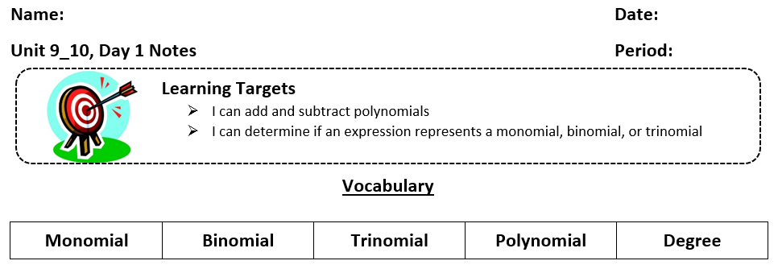

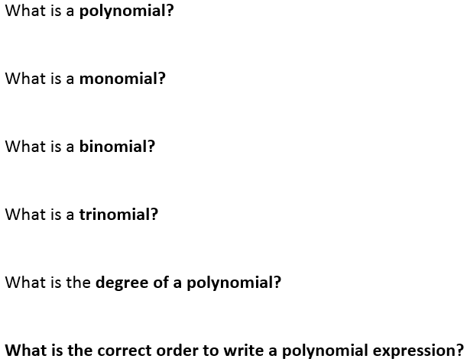
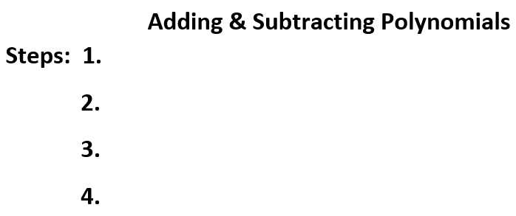

Example 1: Write as an equivalent expression.
$$\left(9a^{2}-7a-1\right)+\left(11+2a-8a^{2}\right)$$

Example 2: Simply the expression.
$\left(3y^{3}+5y-6\right)+\left(7y^{2}-2y-9\right)$

Example 3: Simplify the expression.
$\left(2x^{2}+4x-3\right)-\left(-5x^{2}+2x-3\right)$

You try:
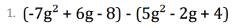 | 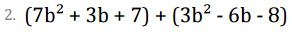
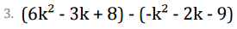 | 